**Responsive Movie Ticket Booking**

**Website**

**Aim:**

Creation of Simple Interactive Application

**Description :**

The **Online Movie Ticket Booking System** is a full-featured web application developed using **HTML**, **CSS**, **JavaScript**, and **PHP**. It allows users to easily book tickets for different movie screens, select seats, input price per seat, and even order snacks. The system also includes user login, an admin panel, booking history, and a modern responsive design.

This project is ideal for learning how to create dynamic, session-based PHP web applications with user interactivity and persistent data.

Github: https://manojkumxr-web.github.io/web/

**CODING:**

<!DOCTYPE html>

<html lang="en">

<head>

    <meta charset="UTF-8">

    <title>Movie Ticket Booking</title>

    <link rel="stylesheet" href="css/styles.css">

</head>

<body>

    <h1>Welcome to Movie Ticket Booking</h1>

    <form action="select.php" method="GET">

        <label for="movie">Select Movie:</label>

        <select id="movie" name="movie" required>

            <option value="Avengers">Avengers</option>

            <option value="Batman">Batman</option>

            <option value="Spiderman">Spiderman</option>

        </select>

        <br>

        <label for="date">Select Date:</label>

        <input type="date" id="date" name="date" required>

        <br>

        <a href="snacks.php"><button> Choose Snacks</button></a>

        <br>

        <br>

        <button type="submit">Next</button>

    </form>

</body>

</html>

body {

    font-family: 'Segoe UI', Tahoma, Geneva, Verdana, sans-serif;

    background-color: blueviolet;

    padding: 20px;

}

h1 {

    color: yellow;

    text-align: center;

}

form {

    background: darkblue ;

    padding: 25px;

    border-radius: 12px;

    box-shadow: 0 4px 10px rgba(0,0,0,0.3);

    max-width: 600px;

    margin: auto;

}

label {

    display: block;

    margin-bottom: 12px;

    color: #ccc;

}

input, select, textarea {

    width: 100%;

    padding: 10px;

    margin-top: 6px;

    margin-bottom: 20px;

    border: none;

    border-radius: 6px;

    background-color: #444;

    color: #fff;

}

button {

    padding: 12px 25px;

    background-color: #ff5722;

    color: #fff;

    border: none;

    border-radius: 6px;

    cursor: pointer;

}

button:hover {

    background-color: #e64a19;

}

.seats {

    display: flex;

    flex-wrap: wrap;

    gap: 10px;

    justify-content: center;

}

.seat {

    background-color: #444;

    padding: 10px;

    border-radius: 5px;

    border: 2px solid #888;

}

document.addEventListener("DOMContentLoaded", () => {

    const checkboxes = document.querySelectorAll('input[type="checkbox"]');

    checkboxes.forEach(box => {

        box.addEventListener('change', () => {

            if (document.querySelectorAll('input[type="checkbox"]:checked').length > 5) {

                alert("You can book a maximum of 5 seats.");

                box.checked = false;

            }

        });

    });

});

<?php

$movie = $_GET['movie'] ?? '';

$date = $_GET['date'] ?? '';

?>

<!DOCTYPE html>

<html lang="en">

<head>

    <meta charset="UTF-8">

    <title>Select Seats</title>

    <link rel="stylesheet" href="css/styles.css">

    <script src="js/script.js" defer></script>

</head>

<body>

    <h1>Select Your Seats</h1>

    <form action="confirm.php" method="POST">

        <input type="hidden" name="movie" value="<?= htmlspecialchars($movie) ?>">

        <input type="hidden" name="date" value="<?= htmlspecialchars($date) ?>">

        <div class="seats">

            <?php for ($i = 1; $i <= 30; $i++): ?>

                <label class="seat">

                    <input type="checkbox" name="seats[]" value="Seat <?= $i ?>"> Seat <?= $i ?>

                </label>

            <?php endfor; ?>

        </div>

        <button type="submit">Book</button>

    </form>

</body>

</html>

<!DOCTYPE html>

<html lang="en">

<head>

    <meta charset="UTF-8">

    <title>Booking Confirmed</title>

    <link rel="stylesheet" href="css/styles.css">

</head>

<body>

    <h1>Booking Confirmed!</h1>

    <p><strong>Movie:</strong> <?= htmlspecialchars($movie) ?></p>

    <p><strong>Date:</strong> <?= htmlspecialchars($date) ?></p>

    <p><strong>Seats:</strong> <?= implode(', ', array_map('htmlspecialchars', $seats)) ?></p>

    <p><strong>Total Price:</strong> ₹<?= number_format($total_price) ?></p>

    <a href="index.php"><button>Book Another Ticket</button></a>

    <a href="history.php"><button>View Booking History</button></a>

</body>

</html>

<?php

$bookings = json_decode(file_get_contents('data/bookings.json'), true);

?>

<!DOCTYPE html>

<html>

<head>

    <title>Booking History</title>

    <link rel="stylesheet" href="css/styles.css">

</head>

<body>

    <h1>Booking History</h1>

    <?php if (empty($bookings)): ?>

        <p>No bookings found.</p>

    <?php else: ?>

        <table border="1" cellpadding="10" style="margin:auto;background:#2c2c3e;color:#fff;">

            <tr>

                <th>Movie</th>

                <th>Date</th>

                <th>Seats</th>

                <th>Total price</th>

            </tr>

            <?php foreach ($bookings as $booking): ?>

                <tr>

                    <td><?= htmlspecialchars($booking['movie']) ?></td>

                    <td><?= htmlspecialchars($booking['date']) ?></td>

                    <td><?= implode(', ', $booking['seats']) ?></td>

                    <td>₹<?= $booking['total_price'] ?></td>

                </tr>

            <?php endforeach; ?>

        </table>

    <?php endif; ?>

    <br><a href="index.php"><button>Back to Home</button></a>

</body>

</html>

**OUTPUT:**

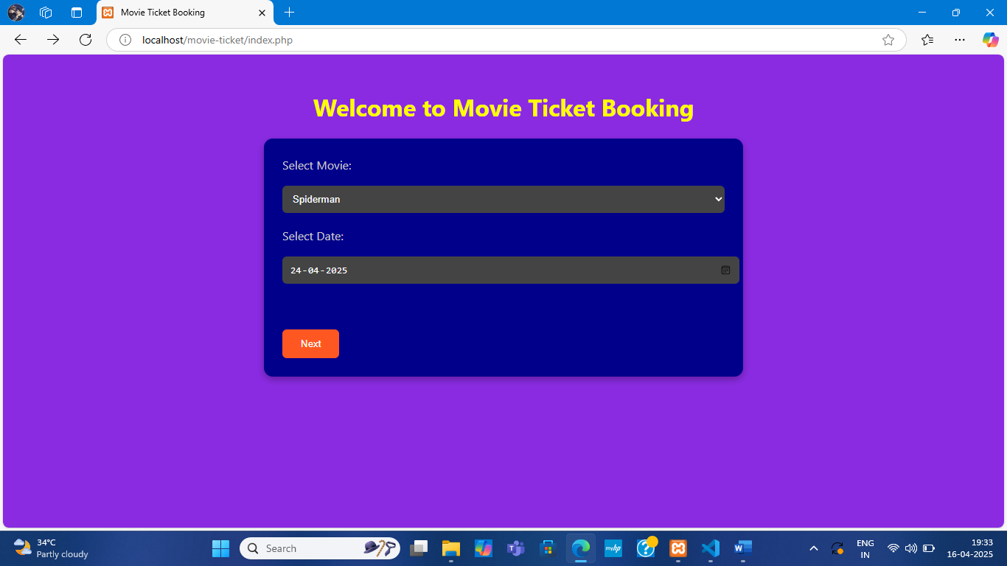

**HOME PAGE**

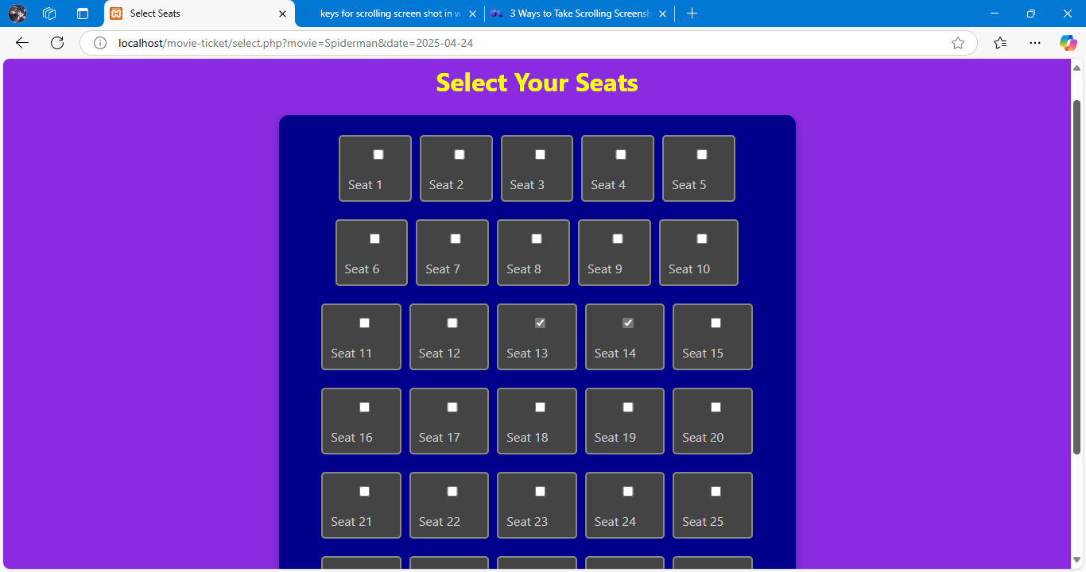

**SELECTION OF SEATS**

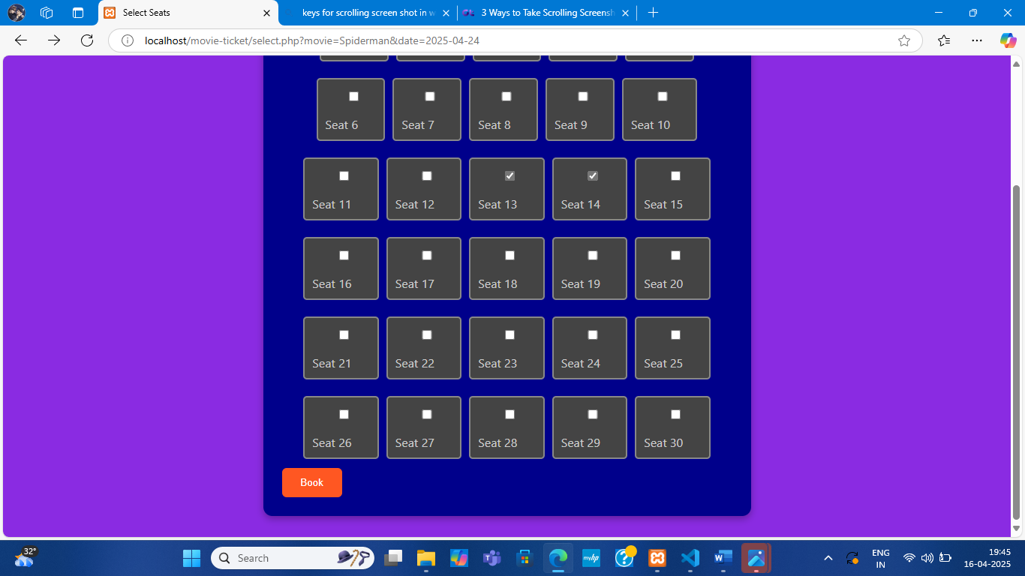

**BOOKING PROCESS**

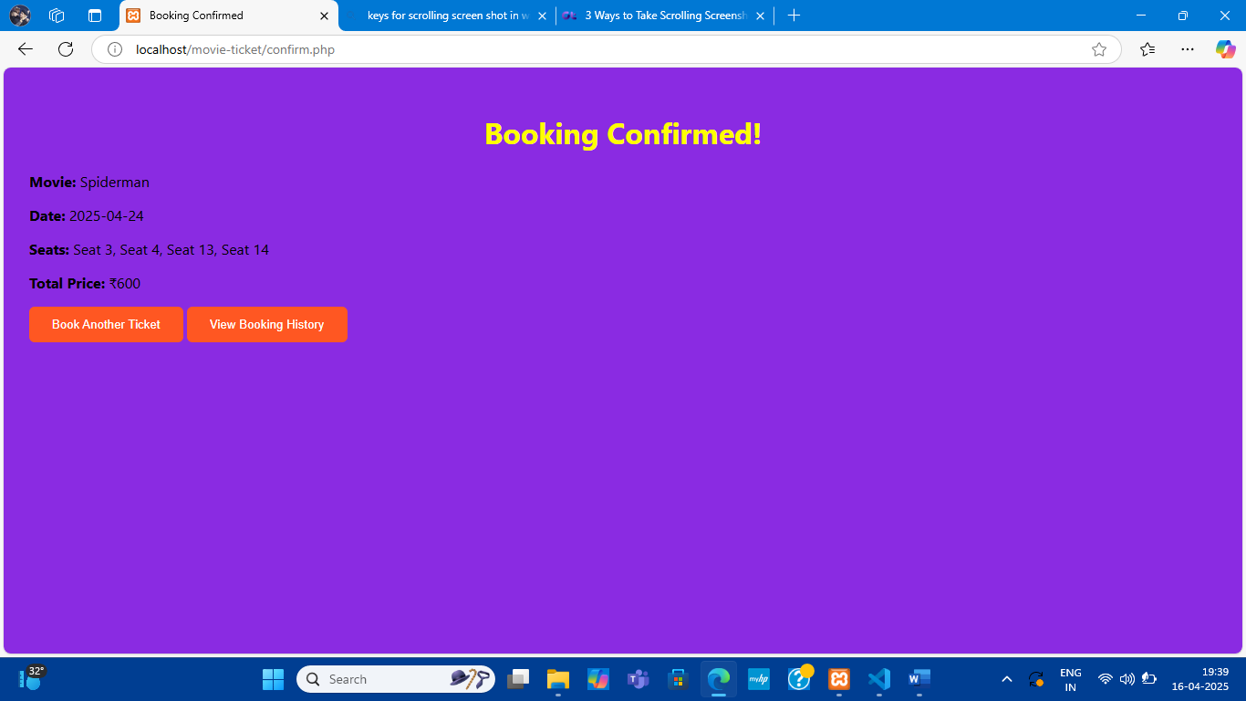

**BOOKING CONFIRMATION**

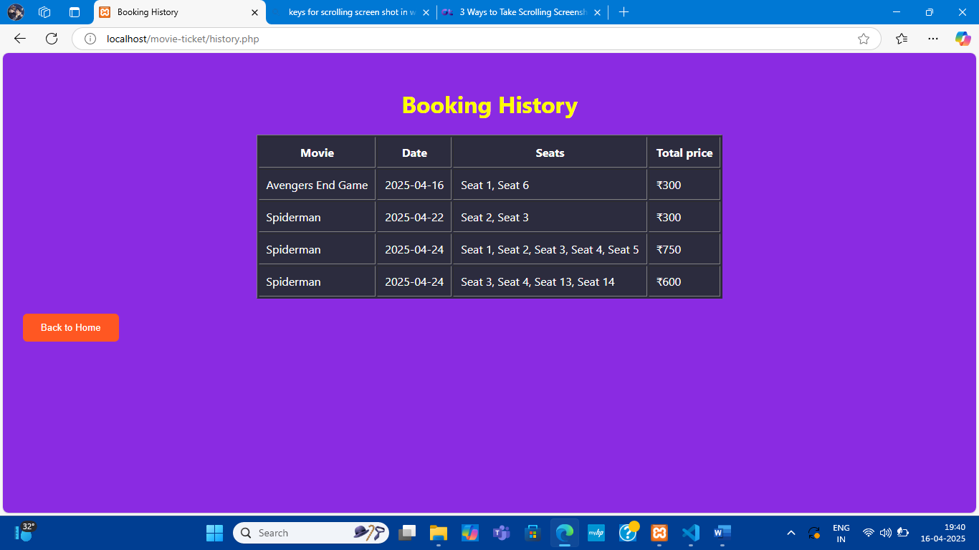

**BOOKING HISTORY**